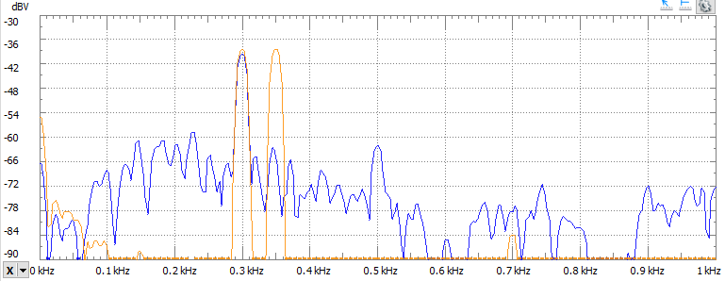

Figure 300 and 350 Hz filtered signal. Yellow is the original signal containing both the 300 and 350 Hz sinusoids. Blue shows the filtered output with only the 300 Hz sinusoid appearing in the output.

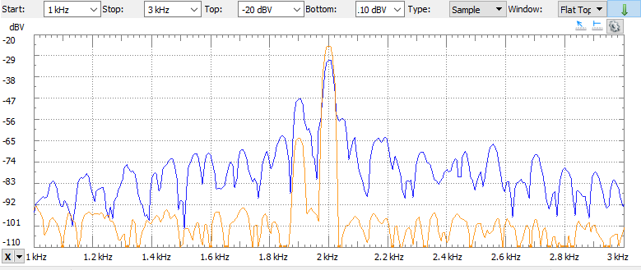

Figure 1.9 and 2.0 kHz filtered signal. Yellow is the original signal. Blue is the filtered signal. The value at 1.9k is slightly boosted, but the signal at 2.0k still appears, even if it is slightly diminished from the original signal.